**Vibe Lift Daily Testing**

**Home Page**

1. Add the “How It Works” tab after “About” on the top menu (see below), to link to the ‘How It Works’ section of the page:

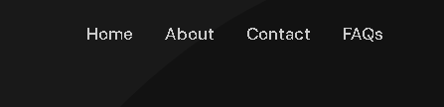

1. Confirm the contact form steps to ensure human is sending the message and not phishing or spam.
2. Change the text as confirmed below:

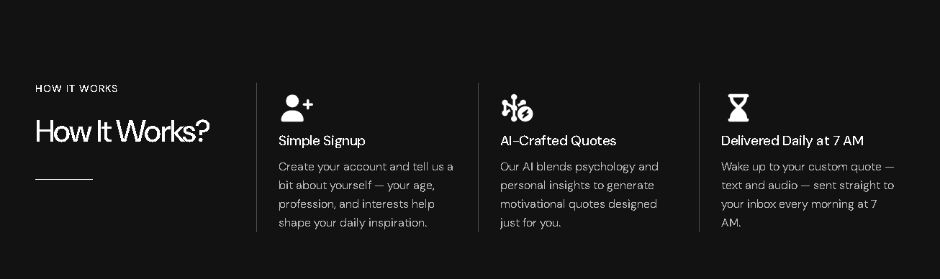

Change ”...to generate motivational quotes...” to “...to generate motivational messages...”

Change “...to your custom quote...” to “...to your custom message..”

**Login**

1. This should say “Login to Vibe Lift Daily” (see below).

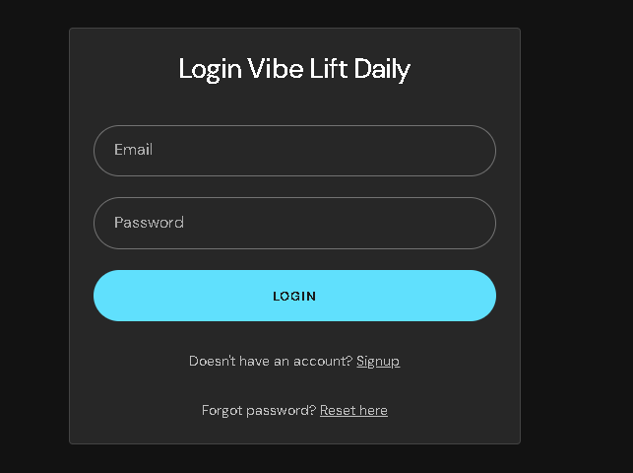

1. This should say “Forgotten password”
2. Change to “Don’t have an account? Signup”

**Start Trial or Subscribe**

1. When registered, this should say “...motivational messages.”

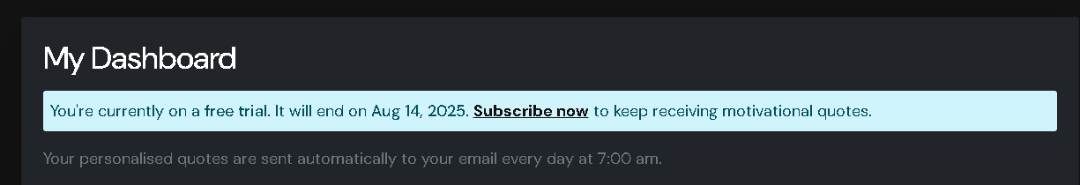

1. While registering, indicate the mandatory fields with an asterix so the user knows which ones are mandatory. The mandatory fields are:

Name

Email

Select Voice

Password

Confirm Password

1. These emails are still not being received. When a user signs up for a trial, a notification email should be sent to [alerts@vibeliftdaily.com](mailto:alerts@vibeliftdaily.com).

**Subscribe**

1. Why is PayPal only coming soon? Do you need my PayPal account to receive subscriber payments? This is in progress; we need to check if PayPal allows recurring payments with Laravel (framework we’re using). Until now I just found that they allow this in Node.JS.

What does this mean?

1. I have subscribed from the UK at £9.99. What is the pricing model set up for other countries? They are converted to user’s currency. Show me example of what they see in other countries.
2. What is ‘Pay with Link’? (see below).

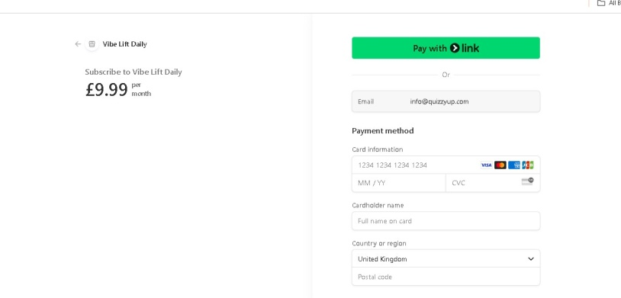

That does not explain what it means, explain please.

1. Does the payment function’s postcode/zip code field accept any country’s code format?

This has not been answered.

1. The payment function’s ‘Terms’ and ‘Privacy Policy’ links are to use the documents provided.  
   This page is shown up by stripe. Pay with LINK is their partner where users can save up their payment methods etc. We have no control on this page This is for Point 3,4,5.
2. What happens if a subscriber’s payment isn’t successful? It will show the error page. Y

What does this mean? An error page to who? What error page? Do the daily messages stop? Clarify for me.

**Subscribe**

1. Change “...receive motivational quotes...” to “...receive motivational messages...”

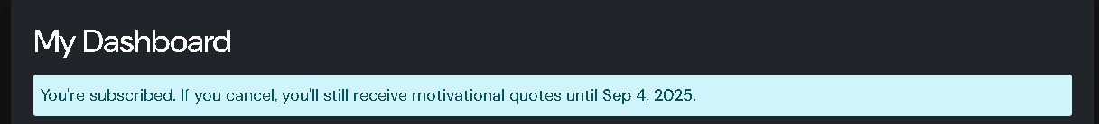

**Admin Management**

1. I still have not been provided with how I manage the backend admin.